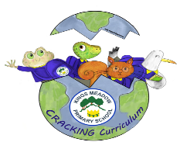
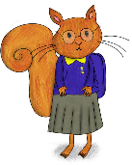


























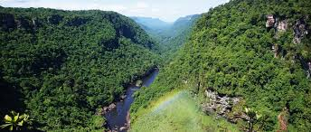
Roots
Overview

In this unit, we will be helping two adopted children find out about their Mexican / Mayan heritage. Through this project, we will also learn about the importance of the rainforest.

The world’s rainforests are found close to the Equator, where the temperatures and rainfall are very high all year. Most tropical rainforests are between the Tropic of Cancer and the Tropic of Capricorn. Make sure you know where to find these on a map and globe. There are large areas of tropical rainforests in South East Asia, West Africa and South and Central America. Tropical rainforests cover 7% of the Earth’s land mass but are home to more than half of the world’s plants and animals. We rely on rainforests for many things - clean air, a stable climate, medicines, bananas, citrus fruits, chocolate and coffee beans, to name a few.
The Rainforest Alliance is a global charity that raises awareness to protect and positively change the future of the rainforests and the lives of the people and animals who live there.
Where?

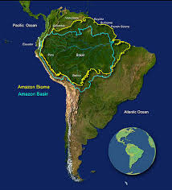

When?

The Mayan empire began around 2000 BC / BCE and ended around 900 AD / CE.

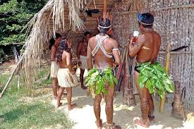
Who?

The Mayan Civilization

Key Events
Date | Event
Around 10,00 BC | Indigenous peoples have lived in the Amazon for thousands of years, developing complex societies, agriculture, and land management techniques such as the Terra Preta (fertile black earth) soil.
1500s AD | The arrival of European explorers like Francisco de Orellana, who was the first to navigate the Amazon River, brought the Amazon to the attention of the outside world.
1600s-1700s AD | European colonization efforts led to the establishment of settlements and missions, impacting indigenous communities through disease, displacement, and conflict.
1800s-1900s AD BC | The discovery of rubber trees in the Amazon led to a boom in rubber extraction. This period saw economic growth but also exploitation and harsh conditions for indigenous and local workers.
1960s-1970s | Large-scale development projects, such as the construction of highways (e.g., the Trans-Amazonian Highway) and dams, began. These projects aimed to integrate the Amazon into the national economies of the countries it spans but led to significant deforestation and displacement of indigenous peoples.
1970s - Present | The Amazon has faced increasing rates of deforestation due to logging, agriculture (particularly soy and cattle ranching), and mining. Satellite monitoring in the 1970s began providing concrete data on the extent of deforestation.
Vocabulary
Canopy Layer: located right underneath the top layer of the rainforest
Deforestation: the action of clearing a large area of trees
Emergent Layer: the tops of trees that poke up above the rainforest canopy (It
is very sunny here and only the strongest and tallest plants
reach this level.)
Equator: an imaginary circle around the middle of the Earth, dividing it into two parts (northern
hemisphere and southern hemisphere)
Forest Floor: the ground (first) layer of the forest.
Rainforest: forests with tall trees, warm humid climate and lots of rain.
Tropical: places that are hot and humid, usually near the equator.
Understory lies between the canopy layer where there is plenty of light and the forest floor
where there is almost none.
r


