Dear Parents,
This term all of our learning will be based around the story of The Gingerbread Man. Stories can bring learning and language to life! We will be sending lots of resources to support and extend learning at home. Here is an overview of some of the exciting learning opportunities your child will be involved in this term.
Our Big Question: What Makes me Unique?
Children will know…
Children will learn the school rules and routines and get to know each other.
❑ All children and people are different and our differences are what make us special.
❑ Our family is unique, children will talk about their family and people who are special to them.
❑ A self- portrait is a picture that we can do of ourselves.
❑ Our body is made of a skeleton which keep us upright and our muscles help us move our body.
❑ Our skeleton is made up of different bones such as: a skull, spine (back bone), hip bone (pelvis), leg bone etc.
- I know what all my senses are used for!
- Explore the natural world around them.
- . Describe what they see, hear and feel whilst outside.
- . Understand the effect of changing seasons on the natural world around them.

Talk For Writing Focus: Goldilocks and The Three Bears.
- What happened to Mrs. Mohammadi’s Gingerbread biscuit?
Investigation – Crime scene! Check the evidence, follow he crumbs!

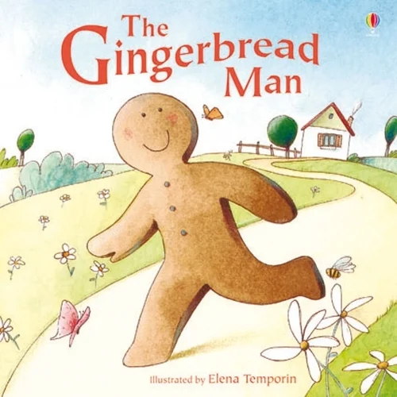

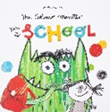

Happy to be Me!
Ways to Support at home!
Watch the story on YouTube.
https://www.youtube.com/watch?v=pckuS--UlV4

You can help your child to blend by using the sound cards.
Watch the clip for some support.
https://www.youtube.com/watch?v=3ovJIxTQpsU

Happy to Be Me – We will be exploring…
- All About Me
- Starting Reception
- New beginnings
- The season of Autumn
- Family
- People who help us
- Diwali
- Halloween
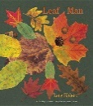
Rhymes of The Week
- If you’re happy and you know it
- Days of the week
- Monday’s Child
- Polly put the kettle on
- The Animal Fair
- The Muffin Man


