Dear Parents,
This term all of our learning will be based around the story of Goldilocks and The Three Bears. Stories can bring learning and language to life! We will be sending lots of resources to support and extend learning at home. Here is an overview of some of the exciting learning opportunities your child will be involved in this term.
Talk For Writing Focus: Goldilocks and The Three Bears.
- Was Goldilocks a naughty girl?
Investigation – Can you design a new chair for Goldilocks?

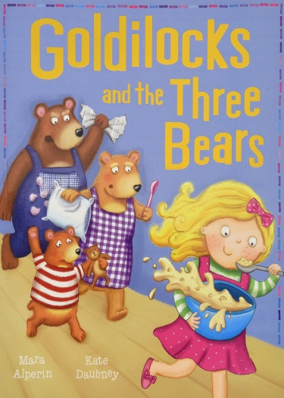
Our Big Question: What Makes me Unique?
Children will know…
Children will learn the school rules and routines and get to know each other.
❑ All children and people are different and our differences are what make us special.
❑ Our family is unique, children will talk about their family and people who are special to them.
❑ A self- portrait is a picture that we can do of ourselves.
❑ Our body is made of a skeleton which keep us upright and our muscles help us move our body.
❑ Our skeleton is made up of different bones such as: a skull, spine (back bone), hip bone (pelvis), leg bone etc.
- I know what all my senses are used for!

Happy to be Me!
Ways to Support at home!
Learn the Goldilocks song!
Scan the QR code and enjoy a sing-along together!
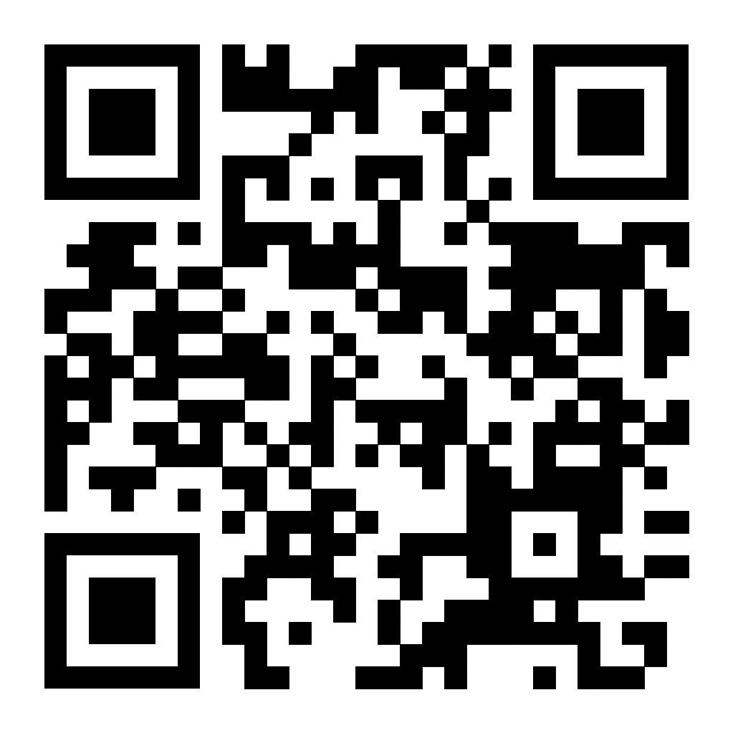

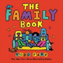
Rhymes of The Week
- I’m a little Teapot
- Tommy Thumb
- Incy Wincy Spider
- Wind the Bobbin up
- Heads, Shoulders, Knees and Toes
- Hickory Dickory Dock

Happy to Be Me – We will be exploring…
- All About Me
- Starting Nursery
- New beginnings
- The season of Autumn
- Family
- People who help us
- Diwali



