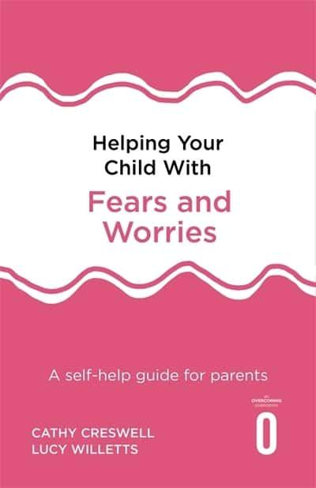
Recommended reading: Helping your Child with Fears and Worries by Cathy Creswell

