Pencil and Handwriting Skills
Child’s Name:
- Which of the following images best depicts your child’s pencil grasp? Please tick the relevant box. If your child’s pencil grasp does not match any of the given images, please supply the therapist with a photo.
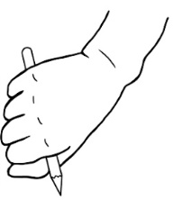 |  | 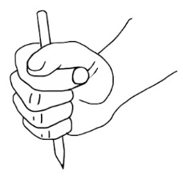 |  | 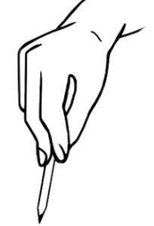 |  | 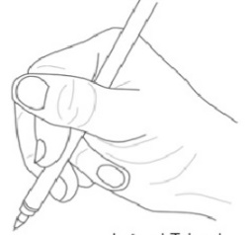
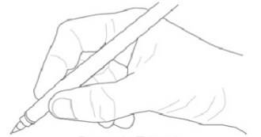 |  | 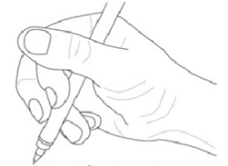 |  | 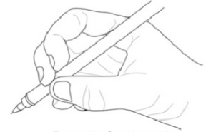 |  | 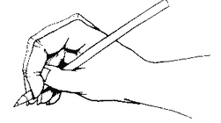
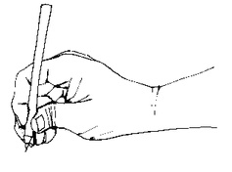 |  | 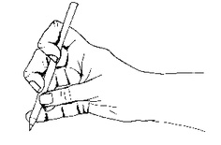 |  | 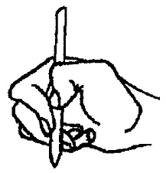 |  | 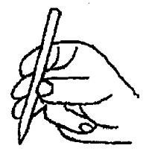

- Does your child have a consistent hand dominance for writing?

If yes, right hand dominance or left hand dominance

If no, does your child show a preference but still switches throughout or show no preference at all

- Is your child controlling their pencil by movements from their wrist whilst holding their fingers static, or are they able to keep their wrist still on the surface and just use isolated finger movements?
Controlling pencil with movements from wrist
Controlling pencil with isolated finger movements

- Does your child complain of pain or aching muscles when writing? Yes / No

If yes, where do they experience pain/aches? Thumb / Fingers / Wrist / Forearm / Shoulder

- Does your child enjoy writing and drawing tasks? Would they choose such activities as a free time option? Writing Yes / No Drawing Yes / No

- Enclosed in your home assessment pack is a pencil control bicycle trail. As a demonstration, please complete half on the top trail so that your child understands what the task entails. As a practice, ask your child to complete the other half of the top trial. Please emphasise to your child to keep within the boundary lines, keep the pen in contact with the paper and to draw the line in one direction towards the house. Your child may need prompts to slow down as necessary to keep within the boundary lines as much as possible. Ask your child to complete the following two trails independently.

- Also, enclosed in your home assessment pack is a handwriting sheet where your child is required to:
- reproduce their alphabet from example
- copy the sentence ‘The quick brown fox jumps over the lazy dog.’ from the example given
- produce their own free writing sentence on the remainder of the writing lines
(Children aged 9+ will not have this sheet in their home assessment pack as they will be completing the DASH assessment instead)

- Does your child correctly form the letters of the alphabet? Yes / No
For example:
- Do the following letters (c, o, a, d, g, q) start with the initial formation of a letter c and does your child keep their pencil on the page until the letter is completed or do they form the letter in two separate parts?
- When forming the following letters (r, n, m, h, p, b), does your child start at the top and dive down or are they forming letters from the bottom up?

- Does your child still consistently reverse certain letters and numbers? Yes / No

Please return this record sheet, the handwriting sheet and the pencil control bicycle trail to the Occupational Therapy department at 52 Hoghton Street, Southport PR9 0PN for analysis.

