Occupational Therapy
Muscular Stability
Exercises

Muscular Stability

These exercises target the muscles in the abdomen, back, shoulders and pelvis and the key to strengthening these muscles is making it fun! Strengthening these muscles will contribute to improved posture, postural control and fine motor skills.

* Always make sure that when you are completing any of these exercises that you are breathing! Breath holding allows you to compensate and not use the crucial core muscles that these exercises target

Superman (back extensors)

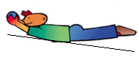
Lying on tummy with arms and legs straight - raise straight arms in front and raise straight legs behind. Hold this position for at least 20 seconds (make sure arms and legs stay straight – children who struggle in this area tend to bend elbows and bring hands back towards body – need to be straight to work the muscles

Gym Ball (shoulder girdle and core stability)

Using a gym ball or with legs on a chair, get into the position shown in the picture. See if you can hold this position straight while you count to 30 slowly. Once you can hold your position on the ball for 20 seconds with 3 repetitions, try bending your elbows slowly so that your nose lowers towards the floor and then push back up into position.

Bridging (pelvic girdle and core stability)

Lying on your back, bend your knees but keep your feet flat on the floor. Position your feet slightly apart in line with your shoulders and hips.
Push hard through your heels to lift your bottom off the floor. Be sure to keep your head and shoulders on the ground and your spine in a straight line.

Hold this position for 30 seconds without hips swaying

Half Kneeling (pelvic girdle and core stability)

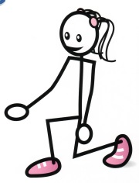
In half kneeling (kneeling with bottom off the floor and with one knee raised), catch a bean bag and throw it into or at a target. You should throw with the side that the knee is weight bearing on the floor and the other hand should be kept on the hip.

Target: 10 repetitions initially, increasing each week by 5 up to a maximum of 20 repetitions each side.

Wall Push Ups (shoulder girdle and core stability)

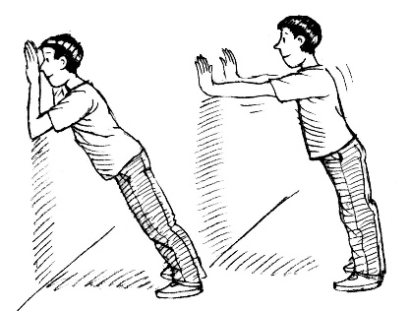
Stand about 1½ arms’ lengths away from a wall and place your hands flat on the wall keeping your arms at shoulder level. Try to bring your face to the wall without moving your feet. Keep your body straight, straighten your arms and push yourself away from the wall. Repeat 10 times slowly.

Floor Push Ups (shoulder girdle and core stability)

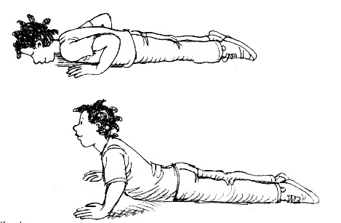
Lie face down on the floor and push your body up with your arms in the same way as a normal press up, but keeping your tummy on the floor. Repeat 10 times slowly.

Jumps (pelvic girdle and core stability)

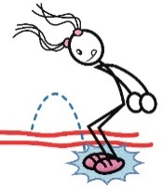
With both feet together, jump forwards and backwards, and side to side over a bean bag or a piece of cord. Ensure that both your feet land together. Repeat 10 times in each direction.

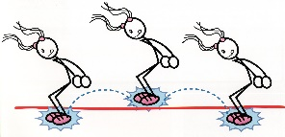
Once you can accomplish single jumps with 10 repetitions, try doing zig zag jumps along a longer line – remember to keep both your feet together.

Wheelbarrow walks (shoulder girdle and core stability)

Wheelbarrow walking is a great way to improve the muscle stability around your shoulders and ideally should be done every day! Make sure that you do not over arch your back or lock your elbows. Try to keep your hands pointing forwards, your legs straight and not wag your bottom!

Bunny Hops (shoulder girdle and core stability)

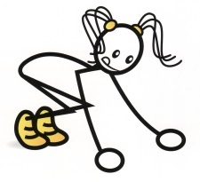
Using a PE bench or similar, place two small mats or spots in front of the bench and slightly apart. Lean forwards and place your hands on the bench equal distance between the two spots and stand with both feet on one spot. Jump from one spot to the other with both feet landing together on one spot.
Target: 20 repetitions initially, increasing each week by 5 up to a maximum of 40 repetitions.

Animal Walks (shoulder & pelvic girdle and core stability)

Can you make it across the length of the room using each of the following animal walks?

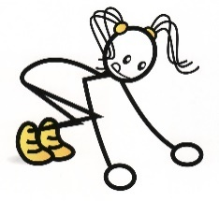
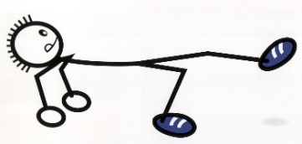
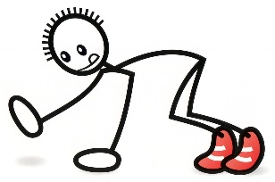
Bear Walks Bunny Hops Crab Walks

Step Ups (pelvic girdle and core stability)

Whilst standing in front of a PE bench, or the bottom step of a staircase, step up leading with the right leg and come down with the right leg as well.

Keep facing forwards at all times. Reverse leading with the left.

Target: 20 repetitions initially, increasing each week by 5 up to a maximum of 40 repetitions.

4pt Kneeling (pelvic girdle and core stability)

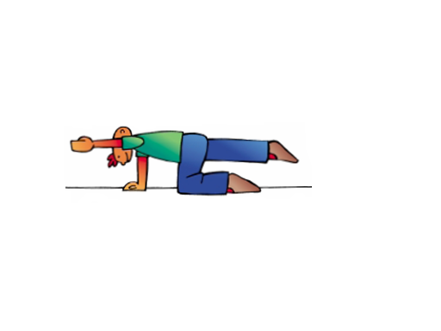
Whilst on your hands and knees, with your hands directly under your shoulders and your knees are directly under your hips, stretch one arm out in front of you off the floor and then stretch the opposite leg out behind you. Keep your body still and straight and see if you can hold this position for 20 seconds, before switching sides.

Moving the Beanbag (shoulder girdle stability)

Hold your arms straight out to the sides with a bean bag in one hand (like a letter T). Raise both arms straight up above your head and swap the bean bag into the other hand before returning the arms back out straight out to the sides - don’t let your arms drop below shoulder height. Continue moving the bean bag from one hand to the other.
Target: 20 repetitions initially, increasing each week by 5 up to a maximum of 40 repetitions.

Tightrope Walker (pelvic girdle and core stability)

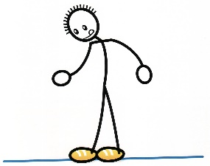
Walk slowly along either a rope line or a drawn line whilst balancing a beanbag on your head. Midway, try stopping and crouching down to pick up an item blocking your path without letting the beanbag on your head drop.
Walking in a heel-to-toe gait is trickier and requires more core stability – can you also crouch down with your heel touching your toe?

Commando Crawling (shoulder girdle and core stability)

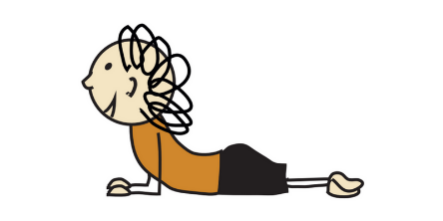
Lying flat on your tummy, use just your upper arms to commando crawl along a series of mats. Keep your legs out straight behind you and try not to use your knees or feet to help move your body forward. It is easier to pull through one arm and then the next as opposed to trying to put both arms out in front of you at the same time.

Ball Curl Ups (core stability)

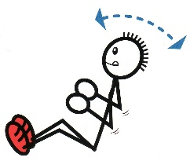
Sit down on the floor with your knees bent, facing a partner. Grasp a football firmly in two hands. Stretch your arms above your head and lie backwards until the football touches the floor. Then sit up again, keeping your bottom and feet glued to the spot, and pass the ball to your partner using two hands. (You may need your partner to help give your feet anchored). Repeat 10 times.

