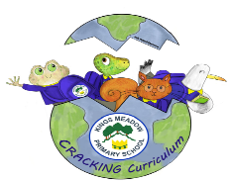



























Overview

A Very Victorian Adventure is a history unit about Victorian England and looks at how the past impacts on the present. We will develop our historical skills, knowledge and understanding through learning about seaside holidays in Victorian England to seaside holidays of today, looking at how they are similar and different and using different sources to look for clues. We will also learn all about Thomas Barnardo to understand the contribution he made to the care of children during the Victorian era.
A Very Victorian Adventure

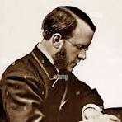

Vocabulary
Adoption / Fostering: To bring up and look after a child that is not a person’s own by birth

Boarding Out: To be taken in by a host family (an early form of Fostering)

Child Evacuee: A child taken away from a place of danger

Donation: Something that is given to charity

Epidemic / Pandemic: A disease that affects a community, a whole country or even the world

Era: A long and distinct period of history

Fundraise: To raise money for a charity

Hardship: Severe suffering or poverty

Medical Missionary: A member of a religious group that is sent to a particular area to promote their faith, whilst giving medical treatment and care

Orphan: A child who has no living parents

Poor: To not have enough money to live at a normal or comfortable standard

Poverty: To be extremely poor

Society: The community of people living in the same area and having shared laws, traditions and organisations

Wealthy: To have a lot of money; to be rich

Where?
Thomas Barnardo was born in Dublin, Ireland in 1845. He moved from Ireland to London in 1866, where he trained to be a doctor, with the intention of being a medical missionary in China. He then stayed in London for the rest of his life.

Who?
During his time training to be a doctor in London, Barnardo saw many children living in poor conditions without food, water, clothing, shelter and no education. This deeply troubled Dr Barnardo and led him to abandon his training as a doctor and, instead, devote himself to helping children living in poverty. As a result, the ‘Ragged School’ was created, providing poor children with a basic free education and he then went on to open his first home for boys. Dr Barnardo soon became an inspiration to many and, after his death in 1905, his legacy lives on through the Barnardo’s charity.

