Sensory Circuits

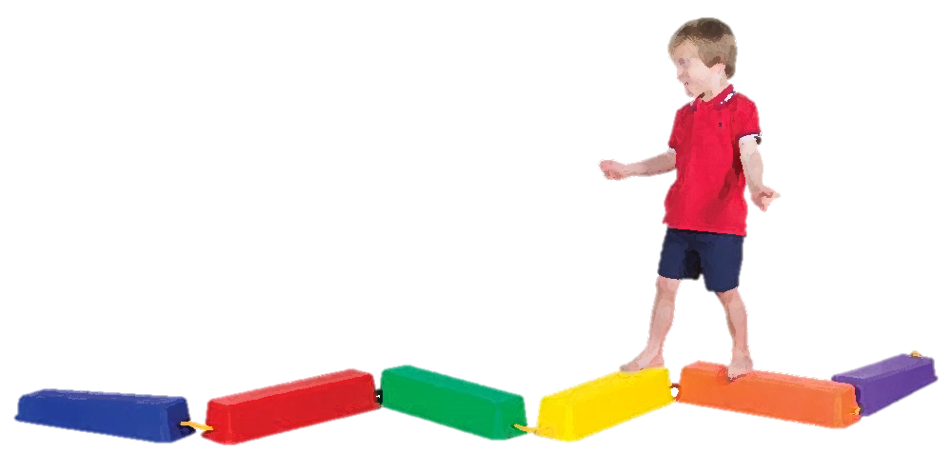


What is a Sensory Circuit?
A sensory circuit is a great way to energise and calm children so they are ready for the school day.
A sensory circuit aims to focus concentration so a child is ready to learn. It will also support the development of a child’s sensory processing skills.

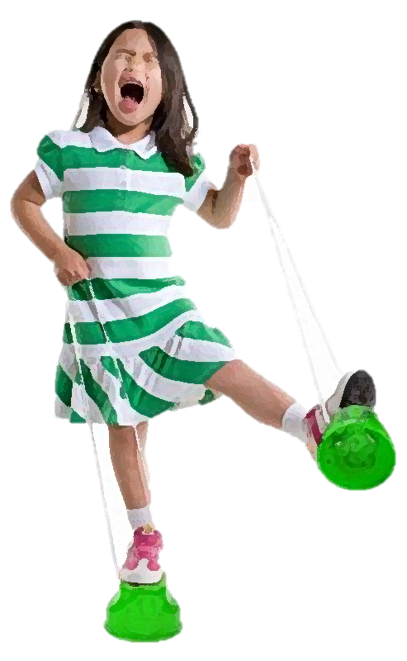

Who would benefit from a Sensory Circuit?
Lots of children would benefit from starting the morning or afternoon with a sensory circuit including children that present with the following behaviours:
- Constant fidgeting in class
- Slow to start work and get going
- Constantly rocking
- Finds it difficult to pay attention
- Poor coordination and balance
- Can be lethargic and dreamy
- Difficulty organising self

How does a Sensory Circuit work?
The Sensory Circuit is a sequence of activities which are repeated to provide a child with the right type of sensory input.
The circuit should be active, fun and physical so that the children enjoy it.
The best times to run a Sensory Circuit are first thing in the morning, and if possible after lunch.
The idea is to start with something alerting, then an organisation stage, and then lastly a calming phase.
The order of a sensory circuit is very important!!

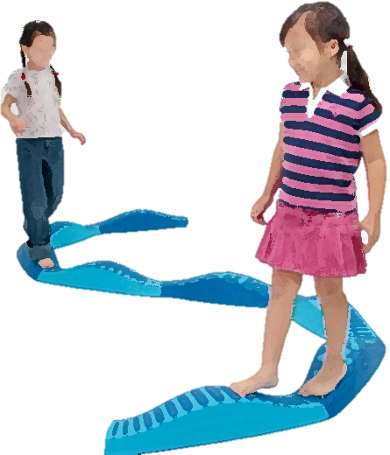


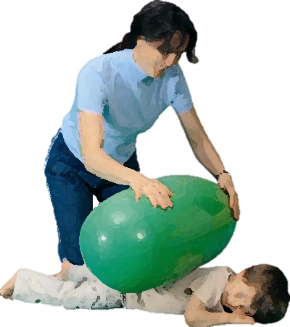
Top Tips!
- Have all the equipment ready for all three parts before you begin.
- Make a list for yourself of the correct order of activities.
- Ideally at 5 minutes for each stage, you can include a couple of activities from each stage.
- Include activities that will aim to restore their sensory balance, not overload them!
- Some individuals may need to spend more time in the alerting activities & a considerable amount of time in the calming section to be as calm, organised and as ready for learning as possible.
- Provide a clear structure to limit chaos. Often a child tries to cope with chaos created by confusion, by creating his or her own predictability; rocking/pacing/stimming.

CALMING SECTION
The calming activities are very important as they provide input to ensure that children leave the circuit and return to class calm, centred and ready for the day ahead.
Activities are proprioceptive or deep pressure.
Examples of activities:
- Lying under a weighted blanket
- Having balls rolled over their backs
- Hot dogs (rolling up a child tightly in a blanket)
- Massage hands, back, feet or shoulders.
- Deep abdominal breaths – in through the nose and out through the mouth

ORGANISING SECTION
This section includes activities that require sensory motor processing, balance and timing.
The child needs to organise their body, plan their approach and do more than one thing at a time in a sequential order.
Examples of activities:
- Balancing on a beam
- Throwing bean bags into a target
- Arm push ups against the wall
- Blowing bubbles or blowing a paper ball
- Wobble boards
- Stepping stones
- Skipping and jumping with a skipping rope
- Crawling through tunnels
- Using a scooter board

ALERTING SECTION
The aim of this section is to provide vestibular and proprioceptive stimulation within a controlled setting.
This prepares the brain for learning.
Examples of activities:
- Bouncing 10 times on a trampette or a space hopper
- Spinning a hoop
- Bunny hops/crab walks/animal walks
- Therapy ball for rolling over and bouncing on
- Skipping
- Walking on stilts
- Star jumps

