Useful Websites
And Contacts

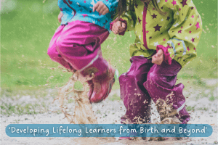

For Parents

Child Development
- BBC: Tiny Happy People
- Development Matters – Government website
- Birth To Five Matters
- What To Expect, When in the EYFS
Resources
- Sefton Family Wellbeing Centres
- Sensory Direct – (Sensory Resources)
- Twinkl – visuals
- Fledglings – adaptive clothing and resources

Toilet Training
- Eric – potty training support and advice

Entitlements and Funding
- Disability Living Allowance (DLA)
- Family Fund
- Merlin’s Magic Wand
- The Sefton Directory – Funded childcare
Sleep
- Sleep Scotland
- The Sleep Charity

Speech and Language
- National Literacy Trust – Tips for talking to your baby/young child.
- Speech and Language UK
- NHS Better Health – Start for Life – Learning to Talk
- Sign Language – Makaton Charity / Signalong / BSL
- Tiny Talkers
Useful Contacts

- Sefton Parent Carer Forum
- National Autistic Society (autism.org.uk)
- Downs Syndrome Association (downs-syndrome.org.uk)
- Contact – charity for families with disabled children.
- Alder Hey Community Paediatrician: commpaedsqueries@alderhey.nhs.uk
- Alder Hey Sensory Team – ahc-tr.sensory.workshops@nhs.net
- Alder Hey Speech Therapy - childrensslt@alderhey.nhs.uk
- Sefton Family Advice and Support (FAST) 0151 934 4545
- Parenting 2000
- SENDIASS
- Sefton Local Offer/SENIS

