About Tourette’s Syndrome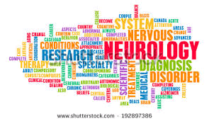
- Tourette’s Syndrome (TS) is a complex neurological condition.
- There is no cure for TS.
- TS is thought to affect one in a hundred school children, with around 300,000 children and adults in the UK living with the condition.
- TS is characterised by involuntary and uncontrollable movements and vocalisations called tics.
- TS is a spectrum condition; no two people with TS will have the same combination of symptoms or tics.
- Around 85% of people with TS will have an additional associated condition; the most common of which are ADHD, OCD and ASD.
- Only 10% of people with TS are compelled to swear (coprolalia).
- Treatment for TS can include medication, cognitive behaviour therapy (CBT), habit reversal therapy (HRT) and deep brain stimulation (DBS).
- TS can make it difficult for a child to learn at school.
- TS can be educationally, economically and socially isolating.

How ADHD Foundation can help
- We strive to raise positive awareness and stamp out the stigma attached to the condition.
- We hold regular support groups for people living with TS and their family and friends.
- We provide TS Awareness training for teachers and other professionals.
- We promote social inclusion, confidence building and youth participation.
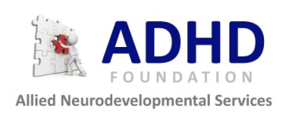
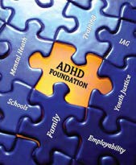

ADHD Foundation and Allied Neurodevelopmental Services
LCVS Building, 151 Dale Street, Liverpool, L2 2AH
Tel: 0151 237 2661
Email: info@adhdfoundation.org.uk
Web: www.adhdfoundation.org.uk
Registered Charity No: 1120898

About Tourette’s Syndrome
- Tourette’s Syndrome (TS) is a complex neurological condition.
- There is no cure for TS.
- TS is thought to affect one in a hundred school children, with around 300,000 children and adults in the UK living with the condition.
- TS is characterised by involuntary and uncontrollable movements and vocalisations called tics.
- TS is a spectrum condition; no two people with TS will have the same combination of symptoms or tics.
- Around 85% of people with TS will have an additional associated condition; the most common of which are ADHD, OCD and ASD.
- Only 10% of people with TS are compelled to swear (coprolalia).
- Treatment for TS can include medication, cognitive behaviour therapy (CBT), habit reversal therapy (HRT) and deep brain stimulation (DBS).
- TS can make it difficult for a child to learn at school.
- TS can be educationally, economically and socially isolating.

How ADHD Foundation can help
- We support children and families living with TS.
- We strive to raise positive awareness and stamp out the stigma attached to the condition.
- We advise on services available to children and families living with TS.
- We hold regular support groups for people living with TS and their family and friends.
- We provide TS Awareness training for teachers and other professionals.
- We promote social inclusion, confidence building and youth participation.

ADHD Foundation and Allied Neurodevelopmental Services
LCVS Building, 151 Dale Street, Liverpool, L2 2AH
Tel: 0151 237 2661
Email: info@adhdfoundation.org.uk
Web: www.adhdfoundation.org.uk
Registered Charity No: 1120898

