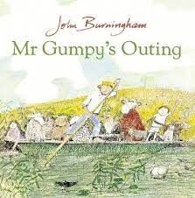
Dear Parents/Carers,
This term, we will be exploring the story of Mr. Gumpy’s outing by John Burningham. It is a beautiful story about kindness and patience. On a lovely sunny day, Mr. Gumpy goes out on a boat ride. Everyone wants to join in. First the children, then the rabbit, then more and more animals. Mr. Gumpy agrees for everyone to jump on his little boat, on the condition that they all get along. But the boat gets more and more crowded, and heavier and heavier and they don’t all get along!
John Burningham (1936-2019) was an English author and illustrator of children’s books. He studied illustration at the Central School of Art in London, and became a prolific writer who wrote and illustrated almost all of his works. Burningham believed in the power of simple and spontaneous illustrations, and loved to mix sketchy line drawings with evocative watercolour painting.
Here is an overview of some the exciting activities linked to our ‘Talk for Writing’ topic.
 | What will we learn? What will we know? | How can you help at home?
Communication & language  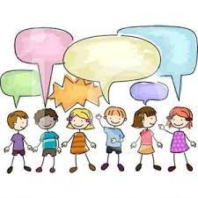 | As the children learn and explore the story. Our children will learn to re-enact the story, getting in role of the different characters. Children will learn to articulate their thoughts and ideas in well-formed sentences.  Children will be able to describe events using talk to help work out problems and organise thinking and activities, and to explain how things work and why they might happen.  Children will be interviewing and meeting Mr. Gumpy himself as part of learning to articulate questions and further knowledge.  Children will be making story maps to record their thoughts, plan a story with them as the main character! This will help children to sequence their thoughts, ideas and add new vocabulary and descriptive language. | Use complete sentences in your every day talk.  Help your child build sentences using new vocabulary by rephrasing what they say and structuring their response.  Narrate events and actions  Remind child of previous events.  Extend their thinking, ‘You thought really hard about building your tower, but how will you know it down?’
Personal, Social and Emotional Development  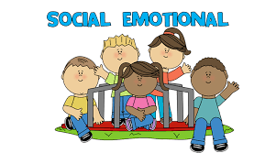 | The focus through this story is to identify and moderate their own feelings socially and emotionally. We will learn about patience, resilience and perseverance, just like Mr. Gumpy! Children will decide who they will take in a boat with limited space! They will consider and think about the perspectives of others.  We will learn about how to be a good friend and what personal qualities we need to become a good friend to others. | To support your child in setting own goals and how to achieve them. Show them mistakes are important part of learning and going back is trial and error – not failure.  Encourage your child to think about their own feelings and those of others by giving explicit examples of how others might feel in particular scenarios.
Physical Development  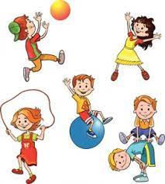 | Our focus through story writing, labelling, writing captions is to develop the foundations of a handwriting style which is fast, accurate and efficient. Children will be making observations and recording their findings as they learn and explore pond/river life. | Encourage your child to draw freely.  Engage your child to engage in structured activities too, guide them in what to draw, write or copy.  Keep practising letter formation!
Literacy  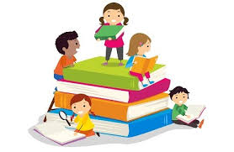 | Children will be learning to write in sentences. We will be encouraging your children to use finger spaces, full stops and capital letters.  Children will be writing speech bubbles for the characters. They will be labelling their own story maps as they become the main character in the story. We will be making our own story books to be shared with you!  We will be reading instructions about how to make a boat and making our own! We will be exploring lots of non-fiction books. | When writing sentences, support your child in saying the sentence before writing. Help your child to memorise the sentence before writing by repeatedly saying it aloud.
Mathematics  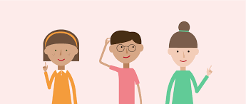 | We will be learning to compare length, weight and capacity.  We will be designing and making our own boats and testing them out! We will be exploring weight and length as we predict how many animals/people can fit in our boats before they sink!  We are learning to automatically recall number bonds for number 0-5 and some to 10. This will be taught through exciting fishing games, how many more to make… if he eats 5 how many will be left etc. | Model comparative language using ‘than’ and encourage your to use this vocabulary. For example, ‘This is heavier than that.’  Ask your child to test and make predictions when playing, ‘What if we pour the jugful into the teapot? Which holds more?’
Understanding The World  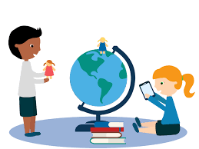 | Through Mr. Gumpy’s journey, we will be learning to draw information from a simple map. We will be learning to recognise that some similarities and differences between life in this country and life in other countries. Children will learn about how important boats are here and around the world and how they are used for different purposes. We will explore and learn about the importance of Fair Trade. We will learning to care for our rivers and local area as we learn about fish and under water creatures. | Get out and explore the world around you! You may like to take a journey yourself to visit you nearest canal and learn about barges/canal boats. You may like to the Pier head in Liverpool and take a trip on a ferry. You may like to use images and video clips on line to research boats around the world.
Expressive Arts and Design  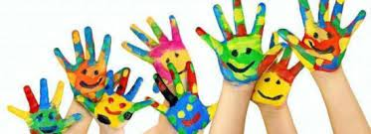 | As we learn about the different designs and purpose of different boats, we will learn about the importance of choice of materials and the effect water has.  We will explore patterns, colour, shades as we learn about under the sea creatures. Children will be able to return to and build upon their previous learning, refining ideas and developing their ability to represent them.  Children will develop storylines in their pretend play and they re-enact Mr. Gumpy’s outing and create and plan their own outing. | Have fun playing with your child at home.  Could you make your own pretend boat at home using boxes, tables, etc…  You could provide a wide range of props for play which encourages a wide rage of props for play which encourages imagination. Support your child in deciding which role they might want to play and teach skills in negotiation, patience and conflict.

