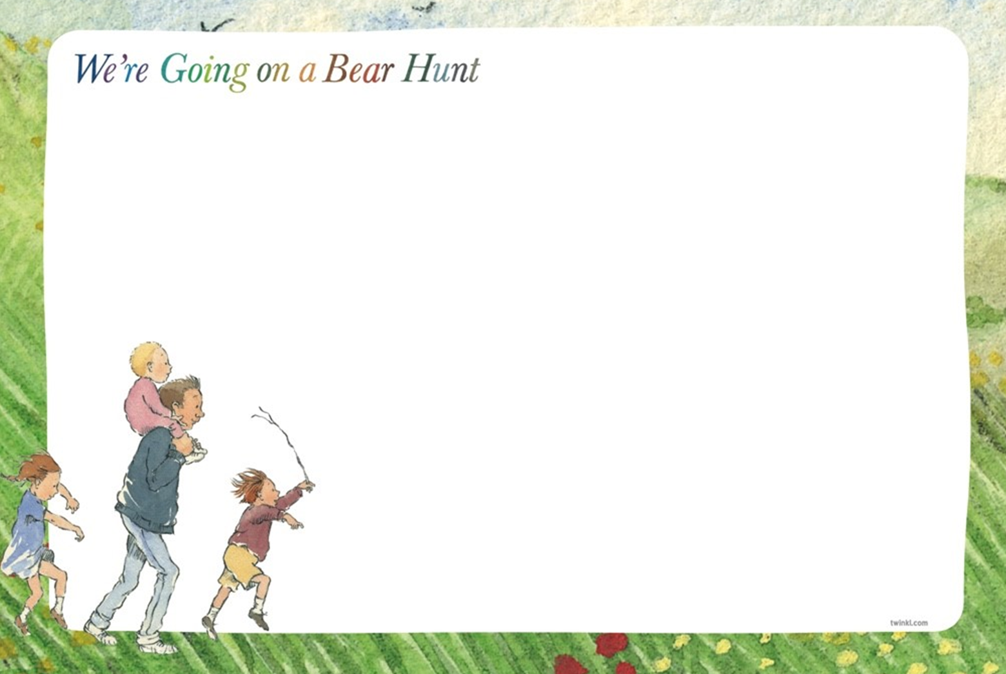
Dear Parents, this term all of our learning will be based around the story of, ‘We’re going on a Bear Hunt’ and the topic of ‘Bears.’ Stories can bring learning and language to life! We will be sending lots of resources to support and extend learning at home. Here is an overview of some of the exciting learning opportunities your child will be involved in this term
PSED: We will be developing friendships linked to children’s interests and will be begin to join in with others play. Through stories and play, we will learn to express our own feelings and learn to recognise other feelings too. We will support the children in expressing their own preferences and interests.
Communication & Language: Children will listen to and join in with repetitive phrases of stories, through bear songs, round and round the garden, teddy bear, teddy bear turn around. We will focus on understanding questions, ‘who’ and ‘what.’ We will develop simple concepts of big/little when sorting the bears.
Literacy: We will be engaging in extended conversations about stories, learning new vocabulary. We will be learning to write some letters accurately. We will be enjoying drawing freely. Children will participate in sharing books with adults and be able to retell the story using props.

Mathematics: We will be learning how to sort objects in different sizes, shapes and colours. We will be exploring and joining in with number songs and rhymes up to five. E.g. 5 little monkeys, 5 little men in a flying saucer.
Understanding the World: We will investigate a range of toys/books that that buttons and switches. Key Vocab – on/off/move/stop/go. We will be learning all about each other’s families and naming the people in our family and our friends in nursery. We will be exploring aspects of the natural world, weather and will be exploring vocabulary to go with it. Key Vocab, Sun/sunny, rain/raining, cloudy/clouds
Physical Development: We will be developing an understanding of action words, e.g, who is jumping, running, walking, climbing. Our focus will be on climbing up and over and under obstacles both indoors and outdoors. Through play, we will develop use of mark making tools through chalks, paint brushes, crayons etc.
Expressive Arts & Design: Children will be learning to identify colours and shapes through lots of exciting bear games/activities. Children will investigate printing through a range of different materials. We will focus on experimenting with the printing of fruit and vegetables. We will be making our own bears with moving parts and will name parts of the bear.

