
Literacy Nursery - Long Term Plan
Kings Meadow Primary School – Our CRACKING CURRICULUM EYFS

Statutory Guidance from the EYFS Framework for Literacy:
It is crucial for children to develop a life-long love of reading. Reading consists of two dimensions: language comprehension and word reading. Language comprehension (necessary for both reading and writing) starts from birth. It only develops when adults talk with children about the world around them and the books (stories and non-fiction) they read with them, and enjoy rhymes, poems and songs together. Skilled word reading, taught later, involves both the speedy working out of the pronunciation of unfamiliar printed words (decoding) and the speedy recognition of familiar printed words. Writing involves transcription (spelling and handwriting) and composition (articulating ideas and structuring them in speech, before writing).

 | Autumn 1 | Autumn 2 | Spring 1 | Spring 2 | Summer 1 | Summer 2
Themes/Interests | Happy to Be Me  All About Me  Starting Nursery  New beginnings  The season of Autumn  Family  People who help us | Join The Celebration  Harvest – Pumpkins  Traditional Tales Christmas Around the World  Celebrations | Let’s Play  Pets, Day and Night animals, On the farm, Jungle, Animals, Animal patterns. | Under the Sea  Spring time, plants and flowers, Easter, Easter arts and crafts. | Food, Glorious Food  Vehicles, space rockets, recycling, using recycled materials. | No Place like home  Summer, The seaside, Teddy bears picnic.
Celebrations & Experiences | Starting Nursery, Autumn trail, Birthdays, Favourite songs, Halloween.  Visit From Fire Service | Harvest time, Bonfire Night, Christmas time, Nativity, Diwali, Nursery Rhyme week.  Visit From Dentist | Lunar New Year / Chinese New Year, visitors with pets. | Planting seeds outside, gardening, nature scavenger hunt, mother’s day, Easter egg hunt. | Creating own vehicles, Eid, Start of Ramadan.  Trip – Knowsley Safari Park | Lighthouse keepers lunch, picnic outside (with families), treasure hunt.
Talk For Writing  Texts  Goldilocks -Autumn1  My Presents-Autumn 2  We’re going on a bear hunt Spring 1  Three Billy Goats Gruff – Spring 2  The Very Hungry Caterpillar -Summer 1  The Gruffalo | 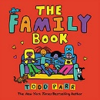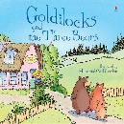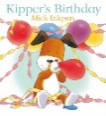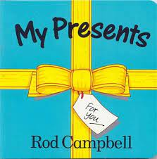 | 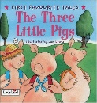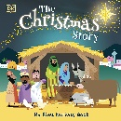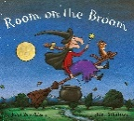 | 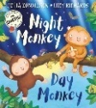  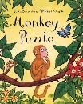  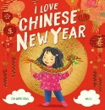  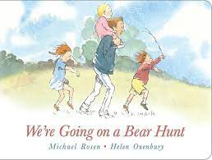 | 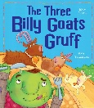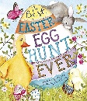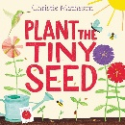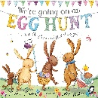 | 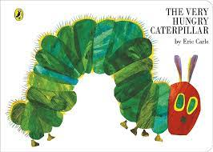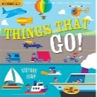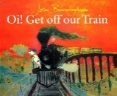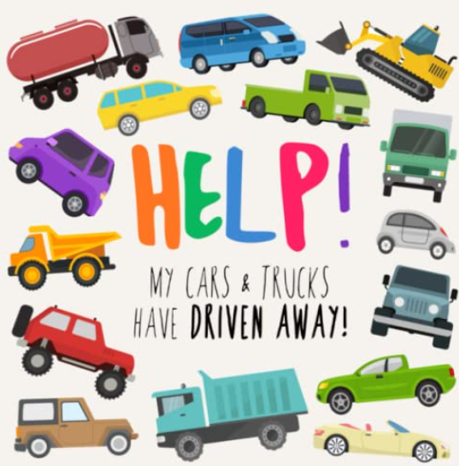 | 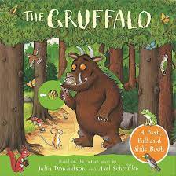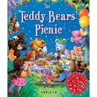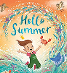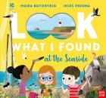
Rhymes Of the Week | I’m a little Teapot  Tommy Thumb  Incy Wincy Spider  Wind the Bobbin up  Heads, Shoulders, Knees and Toes  Hickory Dickory Dock | Here’s the Church…  See Saw Margery Daw  Twinkle, Twinkle Little Star  I hear thunder  The North Wind  Jingle Bells | Miss Polly had a dolly  Humpty Dumpty  This Little Piggy went to Market  Hickety Pickety  Frere Jacques  Sleeping Bunnies | Pat-a-cake  Two Little Dickie Birds  Hot Cross Buns  Baa Baa Black Sheep  Little Bo-Peep  Old Mac Donald had a Farm | Round and Round the garden  Here is a beehive  1,2,3,4,5 Once I caught a fish alive  5 Little Ducks  The Mulberry Bush | Pussy cat, Pussycat  Row, Row, Row your boat  The Wheels on the Bus  Ring a Ring o’ Roses  Ride a Cock Horse  Hokey Cokey  5 Little Monkeys jumping on the bed
The Reception expectations in Literacy for reference. Where are children going? | Comprehension • Demonstrate understanding of what has been read to them by retelling stories and narratives using their own words and recently introduced vocabulary. • Anticipate (where appropriate) key events in stories. • Use and understand recently introduced vocabulary during discussions about stories, non-fiction, rhymes and poems and during role play.  Word Reading • Say a sound for each letter in the alphabet and at least 10 digraphs. • Read words consistent with their phonic knowledge by sound-blending. • Read aloud simple sentences and books that are consistent with their phonic knowledge, including some common exception words.  Writing • Write recognisable letters, most of which are correctly formed. • Spell words by identifying sounds in them and representing the sounds with a letter or letters. • Write simple phrases and sentences that can be read by others.

Literacy – Nursery Long Term Plan
 | Autumn 1 | Autumn 2 | Spring 1 | Spring 2 | Summer 1 | Summer 2
Reading Comprehension  Intent  Vocabulary  Implementation | Beginning to join in with familiar rhymes and stories. Singing some parts or certain Nursery Rhymes. Hears new vocabulary from stories, rhymes, poems and non-fiction books.  Have a favourite book and seeking it/them out to share with an adult or look at alone.  Book, rhyme, join in, picture, illustration, words, text, follow, repeat, look, favourite.  Reading together,  pointing to the words,  talking about the  pictures in books, retell  stories, point out words.  Sing nursery rhymes,  songs and read poems. Children having access to a variety of texts.  (link to themes and  books suggested above) | To understand that we should turn one page at a time in a book. To begin to understand that print has meaning. To talk about the pictures in a book with support.  Texts, books, story, careful, print, words, says, pictures, happening.  Reading together, exploring a wide range of books and discussing them together, Asking questions about books and modelling to the children how to talk about the pictures. | To enjoy singing a range of rhymes and songs. To enjoy listening to longer stories. To join in with some simple repeated refrains in well know stories/ rhymes.  Rhymes, songs, listen, join in, actions, story, repeat.  Daily songs and nursery rhymes, children having story time with increasingly longer stories being told, stories with repetition in them to be shared with the class more than once so children can learn the phrases used. | To begin to understand we read from left to right and top to bottom. To begin to name the parts of a book e.g., front cover, title, author.  Story, words, direction, top, bottom, front, cover, title, author.  Stories shared daily with the children, adults to model reading the story using their finger along the words they read. Adult to tell the children the parts of the book and book title and author when sharing the story with the class. | To enjoy listening to longer stories and remember much of what happens. To talk about a story, turning one page at a time. To answer simple questions about stories. Beginning to predict what might happen in a story.  Story, discuss, talk, questions, predict, guess, happen next.  Children having story time with increasingly longer stories being told, Adults asking children what happens in a story they have already read, or what they think might happen in a story, children having access to stories to read independently | To engage in extended conversations about stories. To know and say how the story might end. To tell a longer story. To listen to and enjoy sharing a variety of books and discuss the new vocabulary learnt.  Discuss, questions, why, end, guess, predict, tell, retell, words.  Daily story time, adults prompting children to discuss the stories they have read, children making predictions about what might happen at the end of a story, a variety of books on offer in nursery.
Word Reading Development  Intent  Vocabulary  Implementation | Hear different environmental sounds around me. Begin to recognise some environmental print such as supermarket logos.  Hearing, listening, sound, recognise, logo.  Support and modelling of listening to environmental sounds. Logos in the environment and in role play areas for children to discuss. | Discriminate between different instrument sounds. To sing and perform actions to a familiar nursery rhyme. Say the rhyming word at the end of a familiar rhyme  Instruments, hear, listen, sing, perform, actions, nursery rhymes, rhyme, join in.  Children listening to instruments as we as having access to using instruments too. Children learning new nursery rhymes and accompanying actions. Children being prompted to say the missing words in known nursery rhymes. | To begin to recognise my own name with support. Recognise rhythm in spoken words by clapping syllables.  Name, rhythm, clapping, syllables.  Children clapping out the syllables in their name as supported by the adults e.g. after dinner before going outside children clapping their name as the outdoor ‘password’. | To identify signs and symbols in the environment and recall what they mean. Spot or suggest rhymes.  Meaning, sign, symbol, logo, rhyme, rhyming words.  Adults to provide a variety of print around the nursery e.g. fire exit, logos, labels for items and areas. Children signing songs and rhymes, playing rhyming games verbally. | To begin recognising some words that start with the same initial sound. To begin to recognise some individual letter sounds with support  Sound, letters, meaning.  Children having access to text in the environment and in books. Letters and sounds around in the nursery for children to have access to and see/speak to adults about. | To recognise my own name independently. To begin to recognise some individual letter sounds with support. Recognise some words with the same initial sound e.g. m for mummy and milk. Orally blend a simple word.  Name, letters, words, same.  Children seeing their name written in a variety of places e.g. peg, bottle, hats, placemats, letters being in the environment, discussions with adults about words with similar sounds, adults supporting children to orally blend words.

Literacy – Nursery Long Term Plan
 |  | Autumn 1 |  |  | Autumn 2 |  |  | Spring 1 |  |  |  | Spring 2 |  |  | Summer 1 |  | Summer 2
Phonics Development  *PLEASE SEE NURSERY RWI HANDBOOK*  Intent  Vocabulary  Implementation |  | Phase 1  Hear environmental sounds (Aspect 1)  Listen, hear, noise, sound, difference, same, similar, loud, quiet, squeak, bark, horn, cars, trees.  Support to listen out for and hear sounds in the environment such as outside and inside – wind, cars, talking. Listening to stories, poems and teachers modelling sounds. |  |  | Phase 1:  Hear environmental sounds (Aspect 1). Hear instrumental sounds (Aspect 2)  Instrument, sound, listen, loud, quiet, different, same  Playing with instruments, listening to the different sounds that can be made using them, exploring loud and quiet sounds, discussing the sounds that have been made. |  |  | Phase 1:  Hear environmental sounds (Aspect 1). Hear instrumental sounds (Aspect 2)  Hear Body percussion (Aspect 3)  Listen, sound, rhythm, pattern, clap, slap, hit, and stomp.  In guided groups – clapping, copying different sounds using the body like stomping, tapping, hitting legs gently and prompting children to discuss the sounds they’ve made.  INTRODUCE RWI -SET 1 SOUNDS |  |  |  | Phase 1:  Revise Aspects 1-3. Hear voice sounds (Aspect 6).  Oral blending and segmenting (Aspect 7)  Speech, voice, sound, vocal, loud, quiet, same, different.  Discussing the difference in vocal sounds we can make, listening to adults model different vocal sounds and repeating these, listening to oral segmenting and bleeding being modelled.  INTRODUCE RWI -SET 1 SOUNDS |  |  | Phase 1:  Revise Aspects 6-7.  Hears rhythm and rhyme (Aspect 4). Hears alliteration (Aspect 5)  Rhyme, rhythm, listen, sound, same, similar.  Listening to stories and rhymes with alliteration and rhyme in, children playing rhyme games, children finishing off words in a known rhyme or suggesting words that can rhyme.  INTRODUCE RWI -SET 1 SOUNDS |  | Phase 1/2:  Revise Aspects 4 – 7.  Possible introduction to Phase 2 if children are ready for the first set of sounds.  Sound, listen, grapheme, phoneme, letter.  Emphasis on orally segmenting and blending and rhyme. Children introduced to the first Phase 2 sounds – s,a,t,p if ready.  INTRODUCE RWI -SET 1 SOUNDS
Emergent Writing Development / Mark Making  Intent  Vocabulary  Implementation |  | Develop an interest in making marks. I am beginning to distinguish between marks and pictures/drawings.  Marks, pencils, pens, paper, drawing, writing.  Adults to provide children with writing equipment in provision for children to access independently at any time. |  |  | Draws marks that are not always distinguishable. Follows large pattern templates available.  Marks, pencils, pens, paper, drawing, writing, trace, copy.  Adults to provide children with writing equipment in provision for children to access independently at any time. |  |  | Adds some marks to drawings. Adds marks that to them symbolises their name.  Marks, pencils, pens, paper, drawing, writing, trace, copy, meaning.  Adults to provide children with writing equipment in provision for children to access independently at any time. Adults to provide children with access to their written name. |  |  |  | Beginning to give meaning to the marks I make.  Marks, pencils, pens, paper, drawing, writing, trace, copy, meaning.  Adults to provide children with writing equipment in provision for children to access independently at any time. |  |  | Understands that a written word conveys meaning. Name writes with the first letter of their name to ‘sign’ their mark making.  Marks, pencils, pens, paper, drawing, writing, trace, copy, meaning.  Adults to provide children with writing equipment in provision for children to access independently at any time. Adults to provide children with access to their written name. |  | Gives meanings to the marks made. Can pretend to write in a range of contexts. Becoming more confident with name writing – I can write some or all of my name.  Marks, pencils, pens, paper, drawing, writing, trace, copy, meaning, letters, sounds.  Adults to provide children with writing equipment in provision for children to access independently at any time. Adults to provide children with access to their written name.
Handwriting development  Intent  Vocabulary  Implementation  *PLEASE SEE FUNKY FINGERS PLANNING* |  | Sits in a balanced position. Can pretend to write. Can make controlled marks using tools or their finger in sand, glitter etc.  Balance, comfortable, straight, pencil, marks, sand, glitter. .  Adults to provide children with writing equipment in provision for children to access independently at any time. Activities set up for children to write in a range of materials e.g. glitter, sand, mud. |  |  | Makes controlled marks e.g. dots, circles, scribbles. Copies shapes and patterns with developing accuracy.  Writing, mark making, pencils, pens, copy, trace.  Tracing materials available to children, writing materials always available to children. |  |  | Makes smaller controlled lines. Beginning to use a two finger and a thumb grip when writing.  Writing, mark making, pencils, pens, copy, trace, pencil grip.  Tracing materials available to children, writing materials always available to children. Tools with pencil grip support e.g. larger pencils, triangular pencils or pencils with a rubber grip on. |  |  |  | Holds a pencil or tool with a preferred hand.  Writing, mark making, pencils, pens, copy, trace, pencil grip, hand. Tools with pencil grip support e.g. larger pencils, triangular pencils or pencils with a rubber grip on.. |  |  | Uses a two finger and a thumb grip when appropriate.  Writing, mark making, pencils, pens, copy, trace, pencil grip, hand Tools with pencil grip support e.g. larger pencils, triangular pencils or pencils with a rubber grip on. |  | Can use the basis of a three finger pencil grip. Use a pencil or writing tool more confidently to write some letters (e.g. the letter in my name).  Writing, mark making, pencils, pens, copy, trace, pencil grip, hand, letter writing.  Tools with pencil grip support e.g. larger pencils, triangular pencils or pencils with a rubber grip on. Writing provision available at all times for the children to access.
Typical Writing development from Nursery to the Reception Year and beyond.
 | - Pre writing |  |  |  |  |  | - Letter strings |  |  |  |  |  |  |  |  | - Early developmental spelling
Early Steps | I explore making marks, but I do not communicate meaning.  Random scribbling.  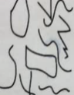 |  |  | I draw pictures.  I use lines to look like writing. Scribble writing  Left to right direction  I begin to assign meaning.  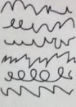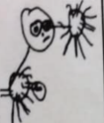 |  |  | I write symbols and shapes that look like writing.  I assign meaning to the marks  Attempts to write name  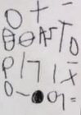 |  |  | I write random letters with no connection between letters and sounds. I talk about my writing.  Writes name from memory  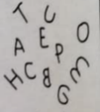 |  |  | I use letter strings which travel from left to right and top to bottom.  I attempt to ‘read’ my writing.  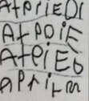 |  |  | I write letters with spaces between them to resemble the idea of words. |  | I copy words that I see in the environment around me.  I often do not know what the words say.  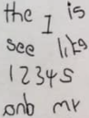
Developing Writing  Words | I am beginning to hear initial sounds and attempt to write these down.  m - mum  letter for name |  | I can hear initial sounds in words and write the letters down to match.  c - cat  d- dog  p - pig |  |  | I can write short strings of letters to represent words. Two or three letters in sequence. Hearing /writing final sounds first and then medial. Left to right.  muy - mummy  sbr - strawberry |  |  | I can spell out and write down vc cvc words by matching letters and sounds.  at in up  cat  dog  pig |  | I can write High Frequency decodable and tricky words from memory.  mum dad. and can  I go to the no into |  |  | I can spell out words with consonant clusters, vowel digraphs and trigraphs.  buzz fill. mess  ship. chip thing rush  boat sheep now soil  chair night. Pure. |  |  | I write more challenging words with a sound knowledge of Phase 2, 3 and 4 phonics. Plausible attempts  Phase 2, 3 and 4 HF words  Adjacent consonants
Developing Writing  Sentences | I can formulate and say a simple sentence for writing. |  |  | I can orally compose a sentence and hold it in my memory before I start to write it.  Repeats & recalls |  |  | I can write a series of beginning letters and sounds for my phrase. There may be no spaces between words.  Begins to be readable to others.  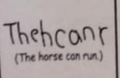 |  |  | I can recall the order of words in my sentence. I start to put finger spaces between my words and to use known words. Writing is readable. I start to read my sentence. |  |  | I can write a sentence with a full stop and capital letter. I can re-read it and check that it makes sense. Others can read my sentence.  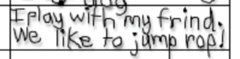 |  |  | I can write spaces between all the words in my sentences. Some punctuation may be used. Medial and end sounds evident including vowels in my spellings. |  | I can write two or more sentences using real spellings and silent letters. Most sentences have the correct beginning and end punctuation.
Text forms and purposes | I attempt to write simple labels. |  |  | I can write simple labels |  |  | I can write simple lists. |  |  | I can write short captions and messages.  I can write lists, greeting cards and menus. |  |  | I can write captions  I can write instructions.  I can write postcards. |  |  | I can write simple stories with a beginning, middle and end.  I can write a letter. |  | I can write stories with narratives and storytelling language.  I can write at length.


