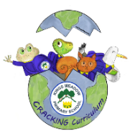
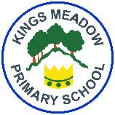
Kings Meadow Primary School

Year 3 | Unit Title: L2-1 What do different people believe about God?  Strand: Believing Worldviews: Christians, Hindus or Muslims | Unit Title: L2-5a  How do people from religious and non-religious communities celebrate key festivals?  Strand: Expressing Worldviews: Christians, Jewish and Non-religious | Unit Title: L2-2 Why is the bible important for Christians today?  Strand: Believing  Worldviews: Christians | Unit Title: L2-4 Why do people Pray?  Strand: Believing  Worldviews: Hindus, Christians, Muslims | Unit Title: L2-4 Why do people Pray?  Strand: Believing  Worldviews: Hindus, Christians, Muslims | Unit Title: L2-7  What does it mean to be Christian in Britain today?  Strand: Living  Worldviews: Christians
Year 4 | Unit Title: L2-10 How do family life and festivals show what matters to Jewish people?  Strand: Living Worldviews: Jewish people | Unit Title: L2-6 Why do some people think that life is a journey? What significant experiences mark this?  Strand: Believing Worldviews: Christians, Jewish people, Hindus | Unit Title: L2-3 Why is Jesus inspiring to some people  Strand: Believing  Worldviews: Christians | Unit Title: L2-8 What does it mean to be a Hindu in Britain today?  Strand: Living  Worldviews: Hindus | Unit Title: L2-8 What does it mean to be a Hindu in Britain today?  Strand: Living  Worldviews: Hindus | Unit Title: L2-9 What can we learn from religions about deciding what is right and wrong?  Strand: Living Worldviews: Christians, Jewish people, non-religious people (e.g. Humanist)
Religious Education Curriculum Coverage and Progression Year 3 and 4
Creative, Real-life, Ambitious, Careers-focussed curriculum building Knowledge & skills for every Individual Nurturing Global citizens of the future

 | Term 1 -Autumn | Term 2 - Spring | Term 3 - Summer



