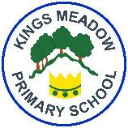
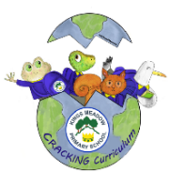
Kings Meadow Primary School
Religious Education Curriculum Coverage and Progression Year 1 and 2
Creative, Real-life, Ambitious, Careers-focussed curriculum building Knowledge & skills for every Individual Nurturing Global citizens of the future
 | Term 1 -Autumn | Term 2 - Spring | Term 3 - Summer
Year 2 | Unit Title: 1-2 Who is a Muslim and what do they believe?  Strand: Believing  Worldviews: Muslims | Unit Title: 1-2 Who is a Muslim and what do they believe?  Strand: Believing  Worldviews: Christians | Unit Title: 1-3  Who is Jewish and what do they believe?  Strand: Believing  Worldviews: Jewish people | Unit Title: 1-  What can we learn from sacred books?  Strand: Believing  Worldviews: Christians, Muslims, Jewish people | Unit Title: 1-4  What can we learn from sacred books?  Strand: Believing Worldviews: Christians,  Muslims, Jews | Unit Title: 1-8 How should we care for others in the world?  Strand: Living  Worldviews: Christians and Jewish people
Year 1 | Unit Title: 1-1  Who is a Christian and what do they believe?  Strand: Believing  Worldviews: Christians | Unit Title: 1-1  Who is a Christian and what do they believe?  Strand: Believing  Worldviews: Christians | Unit Title: 1-7  What does it mean to belong to a faith community?  Strand: Living  Worldviews: Christians, Muslims, Jewish people | Unit Title: 1-6  How and why do we celebrate special, sacred times?  Strand: Expressing  Worldviews: Christians, Muslims, Jewish people | Unit Title: 1-5  What makes some places sacred?  Strand: Expressing  Worldviews: Christians, Muslims, Jewish people | Unit Title: 1-5  What makes some places sacred?  Strand: Expressing  Worldviews: Christians, Muslims, Jewish people



