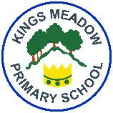
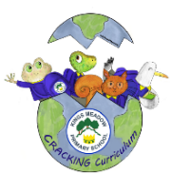
Kings Meadow Primary School

Religious Education Curriculum Coverage and Progression Nursery and Reception
Creative, Real-life, Ambitious, Careers-focussed curriculum building Knowledge & skills for every Individual Nurturing Global citizens of the future
Foundation Stage | Unit Title: F1  Which stories are special and Why?  Strand: Believing  Worldviews: Christians, Muslims, Jewish people | Unit Title: F4  Which times are special and why?  Strand: Believing  Worldviews: Christians, Muslims, Jewish people | Unit Title: F2  Which people are special and why?  Strand: Believing  Worldviews: Christians | Unit Title: F3  Which places are special and why?  Strand: Believing  Worldviews: Christians, Muslims, Jewish people | Unit Title: F5  Where do we belong?  Strand: Believing  Worldviews: Christians, Muslims, Jewish people | Unit Title: F6  What is special about our world?  Strand: Believing  Worldviews: Christians, Muslims, Jewish people

 | Term 1 -Autumn | Term 2 - Spring | Term 3 - Summer



